Case 1 (number of GPU tasks = 50, number of CPU tasks = 5)
High parallelism

Fig. 1 shows that the WCRT and variability obtained with the proposed approach are lower than those obtained using the other methods. The reasons are that, in the used algorithms (LET-LTET-MNAOT), (i) a task with the shortest execution time is selected from the global queue, which can lead to create the next outgoing task(s) earlier and improve the work-conserving of the mapping process, (ii) a local queue with the shortest total execution time is chosen, which can lead to balancing the workload of the queues and improve the load-balancing of the system, and (iii) a task with the largest number of all outgoing tasks is selected from the local queues, which can lead to an increase in the number of ready tasks in the system by meeting their input data dependencies.
Furthermore, the improvements achieved with the proposed approach enhance with increasing the number of computing elements. The reason is that the number of parallel executing tasks is high in this configuration, allowing the selection of the most suitable local queues for the tasks and the selection of the most suitable tasks from them. Note that the response time decreases with increasing the number of computing elements, as tasks are executed with more CPUs and GPUs.

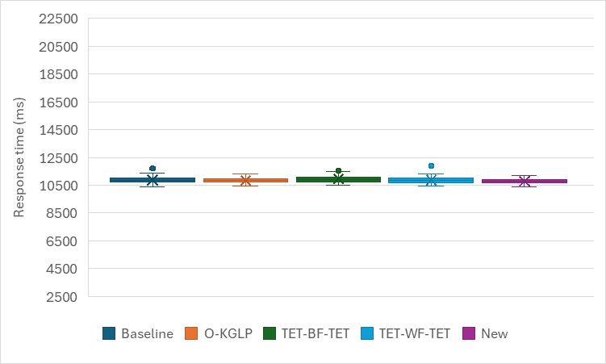  Num_CPU=4, Num_GPU=2 | 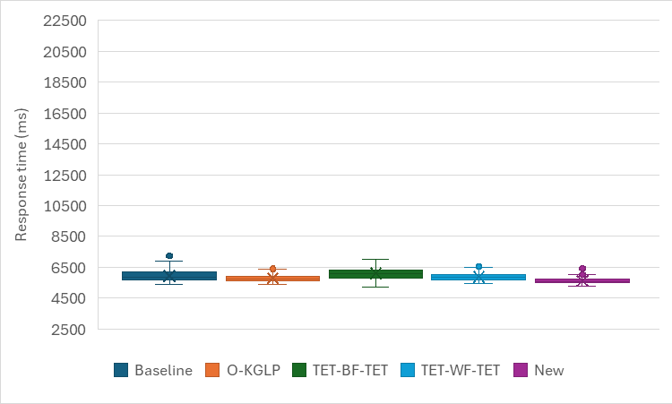  Num_CPU=8, Num_GPU=4
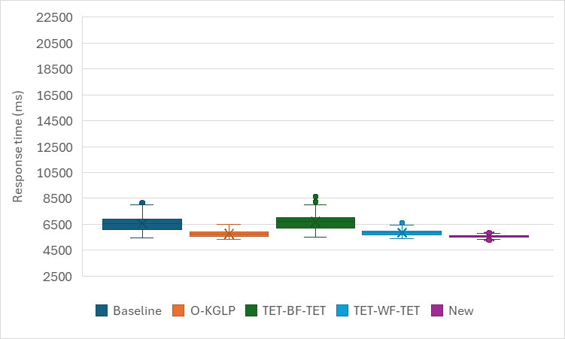  Num_CPU=16, Num_GPU=4 | 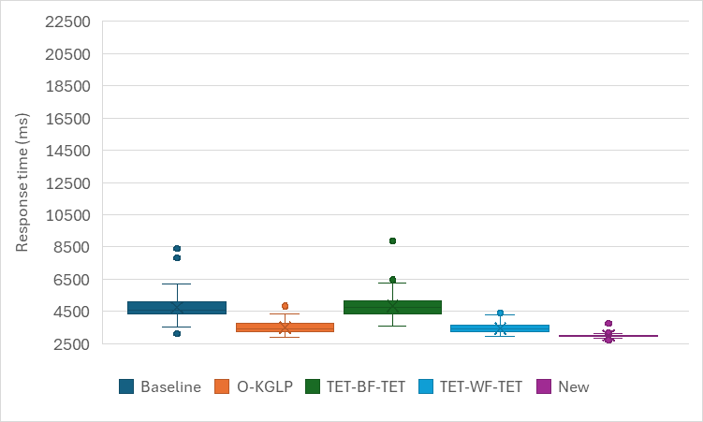  Num_CPU=32, Num_GPU=8
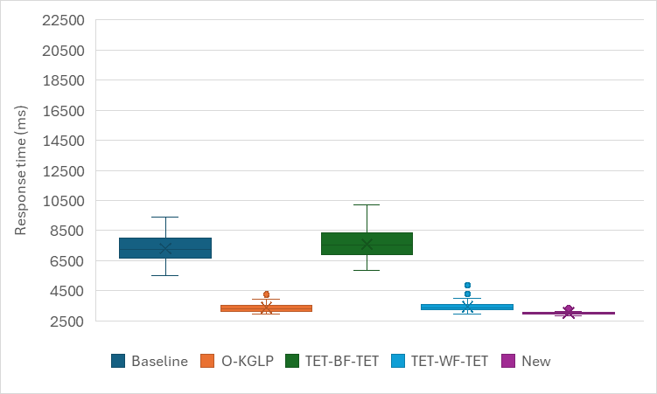
Num_CPU=64, Num_GPU=8
Fig. 1. Simulation results for Case 1 with high parallelism.

Speedup of the new method (standard deviation)
 | Baseline | O-KGLP | TET-BF-TET | TET-WF-TET
Num_CPU=4, Num_GPU=2 | 28% | 17% | 37% | 29%
Num_CPU=8, Num_GPU=4 | 54% | 34% | 56% | 37%
Num_CPU=16, Num_GPU=4 | 78% | 51% | 80% | 52%
Num_CPU=32, Num_GPU=8 | 82% | 65% | 82% | 58%
Num_CPU=64, Num_GPU=8 | 86% | 64% | 87% | 60%
Average | 65.60% | 46.20% | 68.40% | 47.20%

Medium parallelism
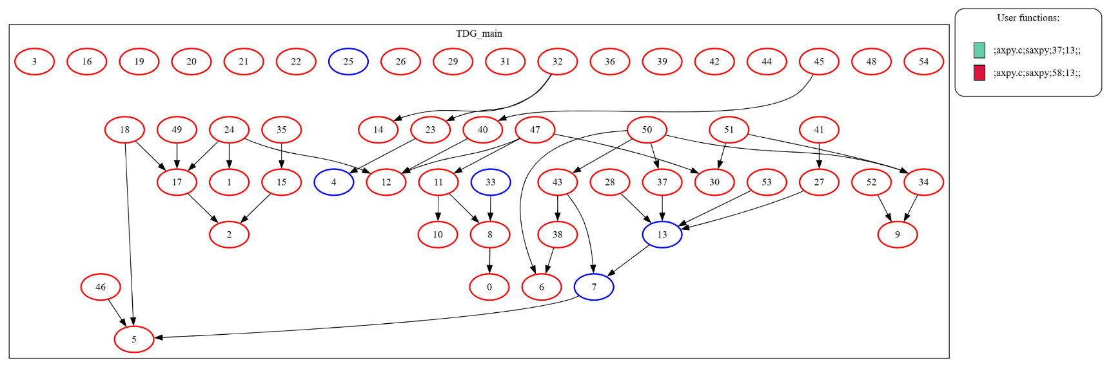
Fig. 2 shows that the new approach obtained similar improvements with those shown in Fig. 1. The only difference is that the improvements decrease after increasing the number of CPUs to 32 and the number of GPUs to 8. The reason is that the number of parallel executing tasks is medium in this configuration, so the number of tasks simultaneously allocated to local queues is not much. Therefore, it does not really matter which algorithms are applied to select local queues for tasks and which ones to choose from. Another difference is that the response time increases as the number of data dependencies increases, so tasks wait to meet input data dependencies.
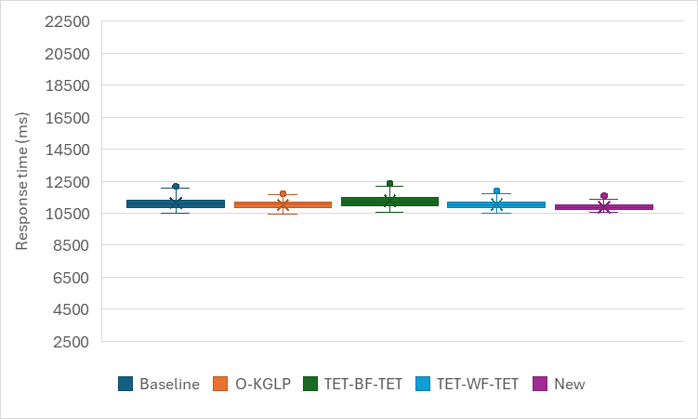  Num_CPU=4, Num_GPU=2 | 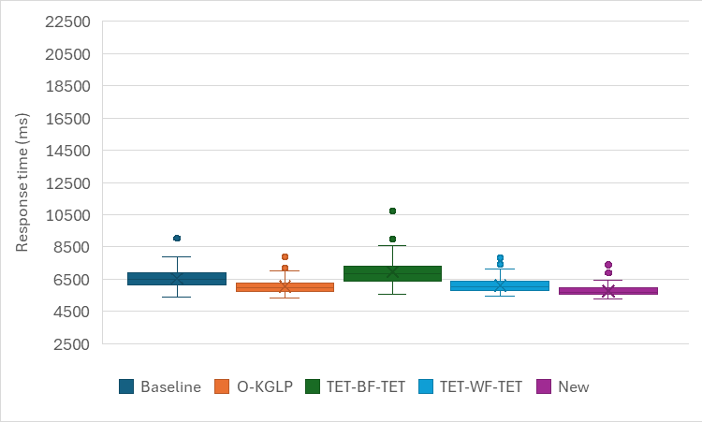  Num_CPU=8, Num_GPU=4
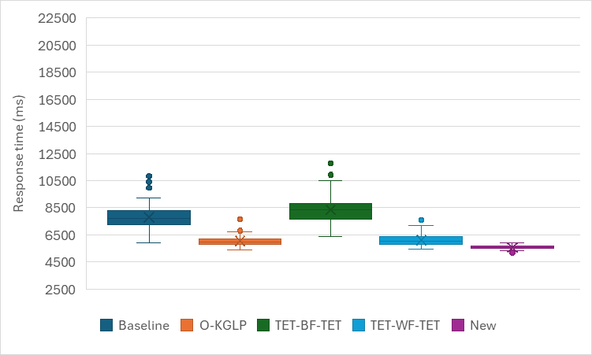  Num_CPU=16, Num_GPU=4 | 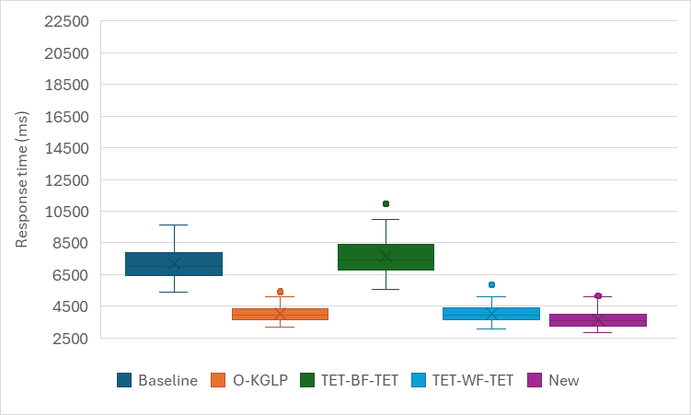  Num_CPU=32, Num_GPU=8
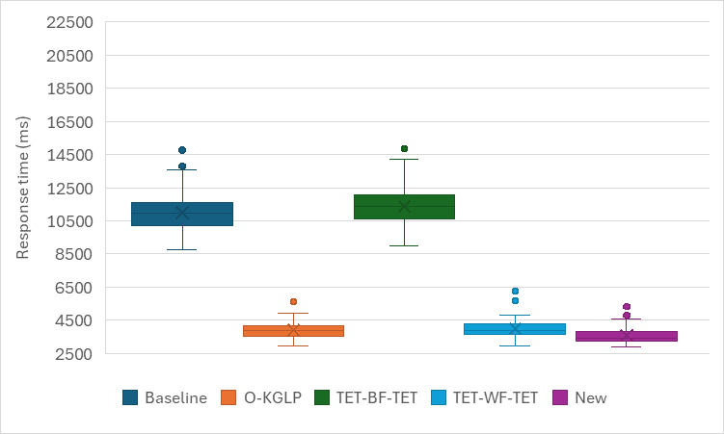
Num_CPU=64, Num_GPU=8
Fig. 2. Simulation results for Case 1 with medium parallelism.

Speedup of the new method (standard deviation)
 | Baseline | O-KGLP | TET-BF-TET | TET-WF-TET
Num_CPU=4, Num_GPU=2 | 43% | 22% | 49% | 25%
Num_CPU=8, Num_GPU=4 | 44% | 22% | 58% | 24%
Num_CPU=16, Num_GPU=4 | 86% | 69% | 87% | 69%
Num_CPU=32, Num_GPU=8 | 50% | 4% | 55% | 6%
Num_CPU=64, Num_GPU=8 | 59% | 3% | 61% | 9%
Average | 56.40% | 24.00% | 62.00% | 26.60%

Low parallelism
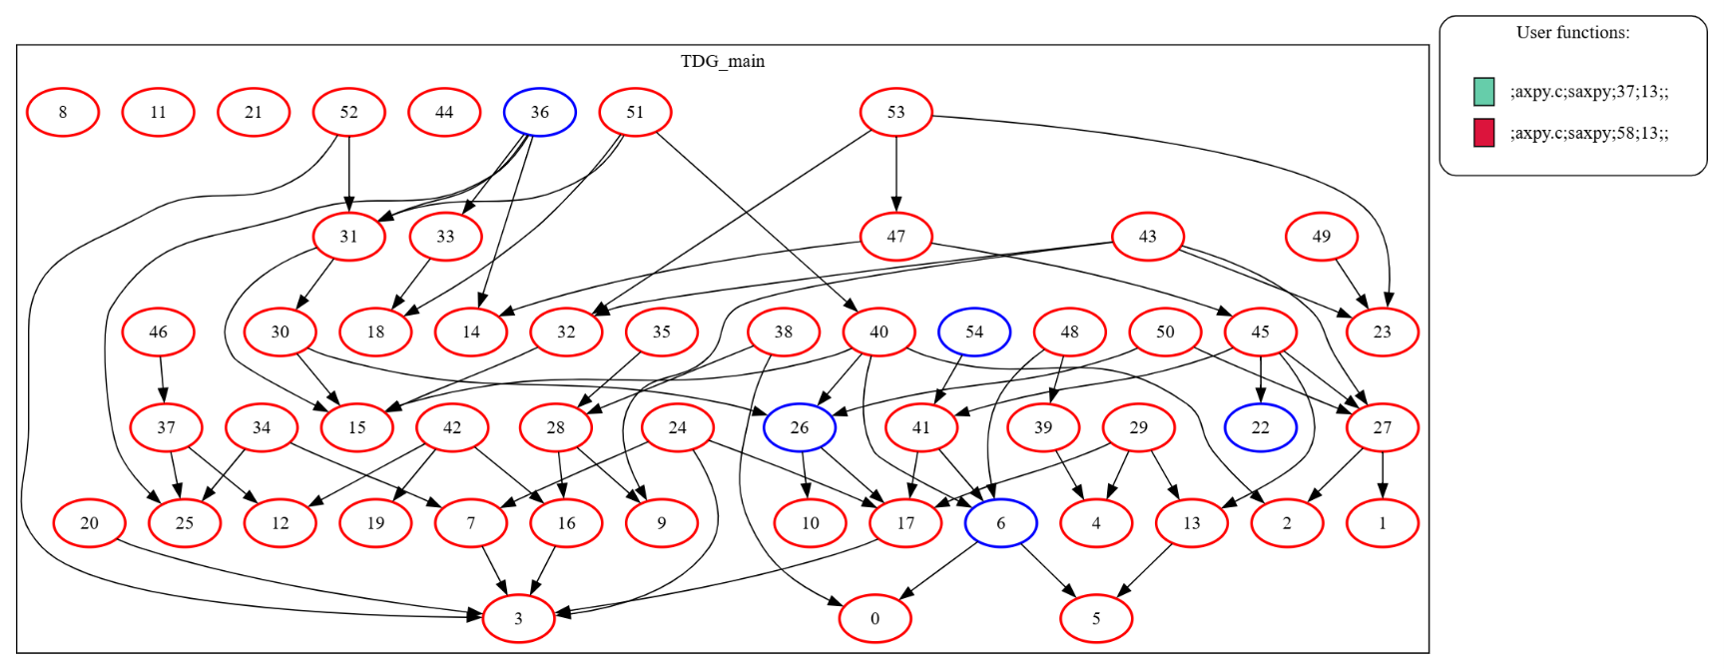

Fig. 3 indicates that the improvements in WCRT and response time variability achieved with the proposed approach are not considerable, compared to the previous results (Figs. 1 and 2). This is because there are many data dependencies between tasks in this configuration, and the number of concurrently executing tasks is very low. Therefore, the efficiency of the suggested algorithms for choosing appropriate local queues and tasks is not remarkable.
However, the new approach still outperforms the baseline and the TET-BF-TET method. There reasons are that (i) in the former, tasks are selected from queues using FIFO, and the first available local queue is chosen for the task selection process, therefore the work-conserving of the mapping process is not high enough, and the workloads of queues are not balanced in terms of task execution time, and (ii) in the latter, the local queue with the most tasks, compared to the rest of the queues, is selected based on the best-fit (BF) algorithm, which reduce the load-balancing and significantly increase the response time.
Moreover, the response time is not reduced using the proposed method, where the number of CPUs is increased to 64 and the number of GPUs to 8. The reason is that the number of tasks executed simultaneously using the computing elements is low, so some of them are idle during the task execution.
Note that the response time achieved in this configuration using the mapping methods is higher than that achieved in the previous configurations (high and medium parallelism). This is because the number of task dependencies is very high, so tasks should wait longer to be ready to execute.

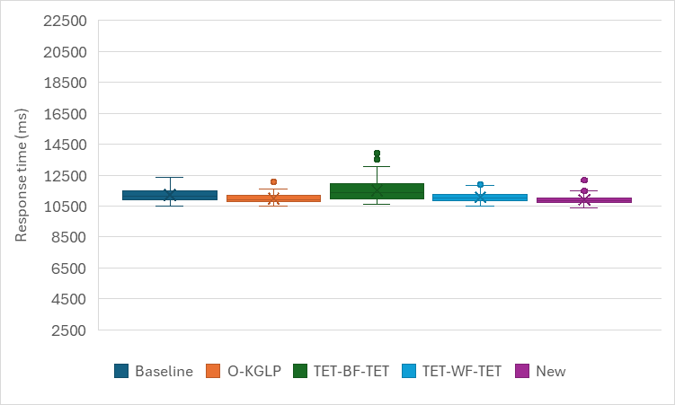  Num_CPU=4, Num_GPU=2 | 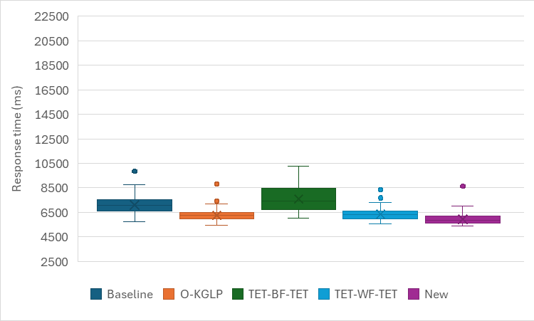  Num_CPU=8, Num_GPU=4
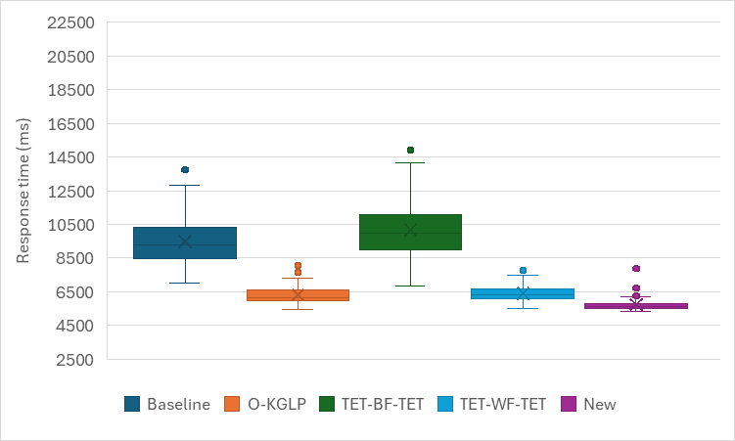  Num_CPU=16, Num_GPU=4 | 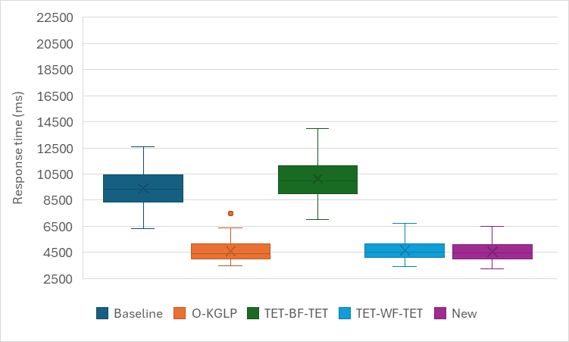  Num_CPU=32, Num_GPU=8
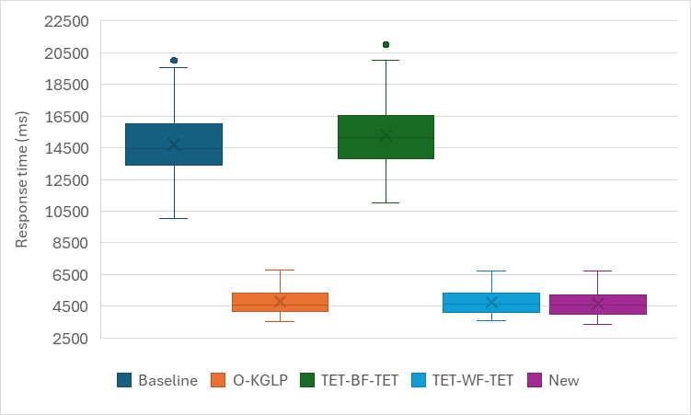
Num_CPU=64, Num_GPU=8
Fig. 3. Simulation results for Case 1 with low parallelism.

Speedup of the new method (standard deviation)
 | Baseline | O-KGLP | TET-BF-TET | TET-WF-TET
Num_CPU=4, Num_GPU=2 | 34% | 13% | 58% | 19%
Num_CPU=8, Num_GPU=4 | 36% | 4% | 54% | 7%
Num_CPU=16, Num_GPU=4 | 75% | 36% | 78% | 31%
Num_CPU=32, Num_GPU=8 | 45% | 2% | 53% | 0%
Num_CPU=64, Num_GPU=8 | 59% | 3% | 59% | -4%
Average | 49.80% | 11.60% | 60.40% | 10.60%

Case 2 (number of GPU tasks = 74, number of CPU tasks = 8)
High parallelism

Fig. 4 shows the effect of a large number of CPUs and GPUs on the efficiency of the mapping methods. The results demonstrate the performance of the proposed approach compared to the previous methods, especially the baseline and TET-BF-TET. Furthermore, the comparison between the results achieved in this case and those achieved in Fig. 1 illustrate that the performance of the new approach is noticeable. The reason is that more tasks are considered in this case, so the new algorithms have a better chance of selecting the most appropriate tasks from the global queue and local queues, as well as choosing the most suitable local queues for ready tasks. This feedback can improve the work-conserving of mapping and the load-balancing of local queues. However, the main improvements are achieved after increasing the number of CPUs to 16 and the number of GPUs to 4. The reason is that the number of tasks is high in this case, so more computing elements are needed to show the performance of the proposed approach.

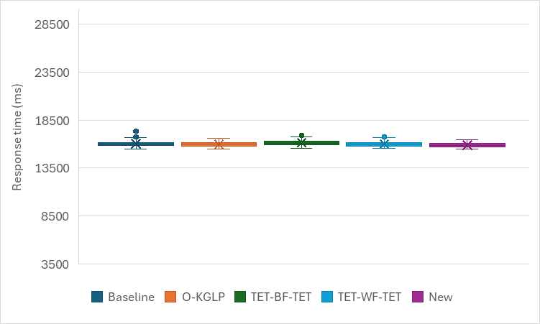  Num_CPU=4, Num_GPU=2 | 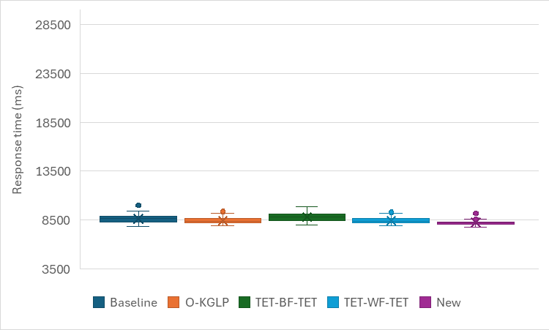  Num_CPU=8, Num_GPU=4
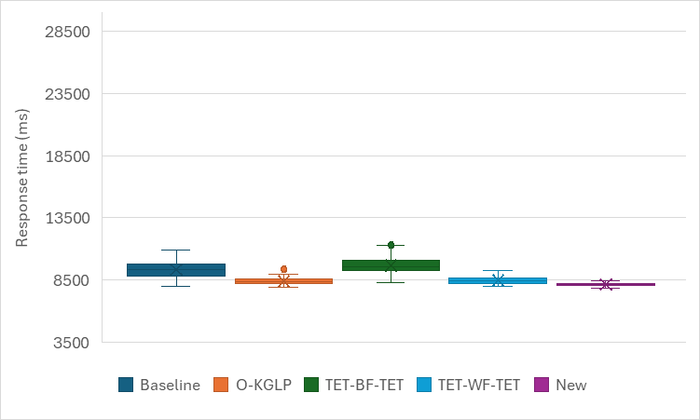  Num_CPU=16, Num_GPU=4 | 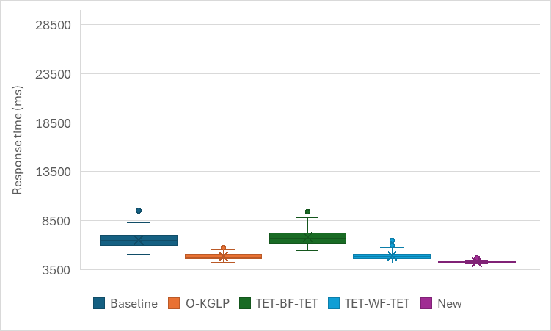  Num_CPU=32, Num_GPU=8
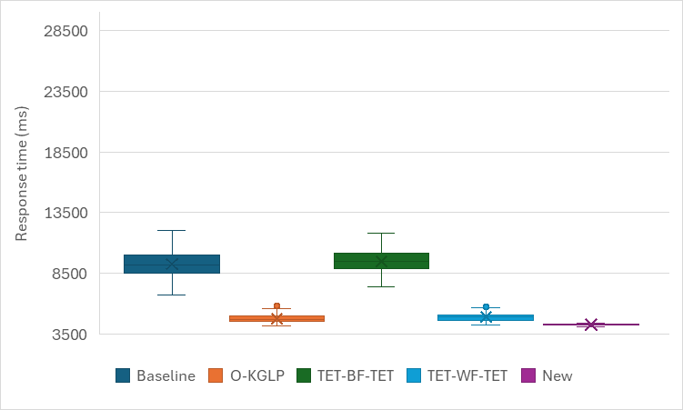
Num_CPU=64, Num_GPU=8
Fig. 4. Simulation results for Case 2 with high parallelism.

Speedup of the new method (standard deviation)
 | Baseline | O-KGLP | TET-BF-TET | TET-WF-TET
Num_CPU=4, Num_GPU=2 | 37% | 19% | 31% | 21%
Num_CPU=8, Num_GPU=4 | 43% | 30% | 46% | 29%
Num_CPU=16, Num_GPU=4 | 82% | 56% | 82% | 61%
Num_CPU=32, Num_GPU=8 | 85% | 66% | 87% | 72%
Num_CPU=64, Num_GPU=8 | 94% | 82% | 93% | 82%
Average | 68.20% | 50.60% | 67.80% | 53.00%

Medium parallelism
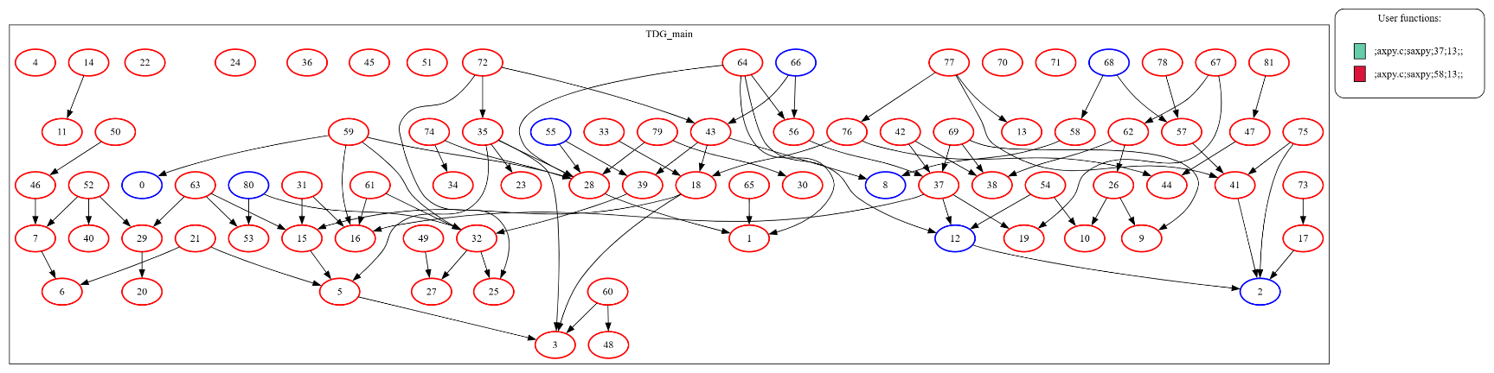

Fig. 5 depicts that the new approach obtained some improvements, especially when more computing elements are available in the system. The reason is that the number of tasks is high in this case, so the inefficiency of the other methods is most noticeable when allocating tasks to unsuitable local queues and selecting inappropriate tasks from the queues. This feedback reduces the work-improving of mapping and the load-balancing of local queues. In addition, the difference between the results achieved in Figs. 2 and 5 indicates that the number of data dependencies between tasks increases as the number of tasks increases, and therefore, the number of tasks executing in parallel decreases. However, in the case of using higher computing elements, the results obtained in Fig. 5 show further improvements, since the most appropriate tasks as well as local queues can be still selected.

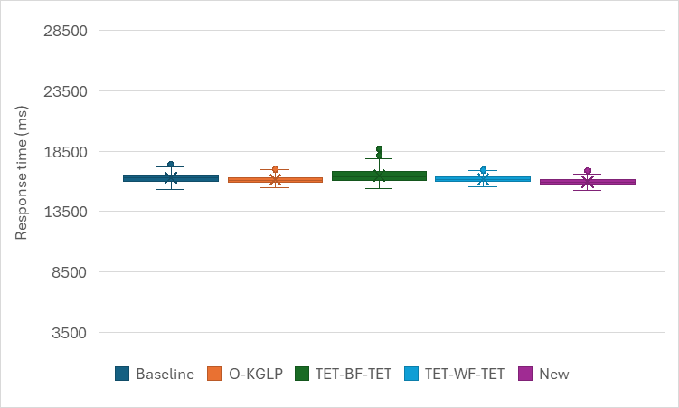  Num_CPU=4, Num_GPU=2 | 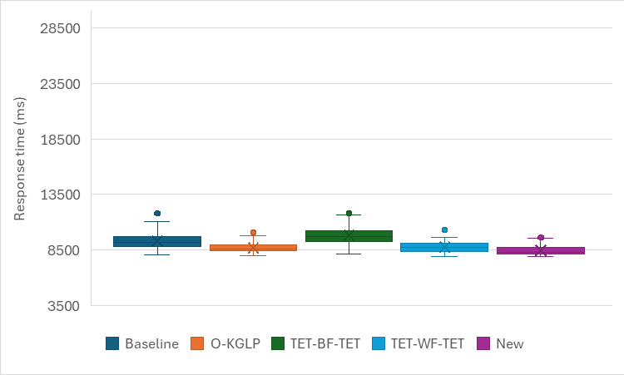  Num_CPU=8, Num_GPU=4
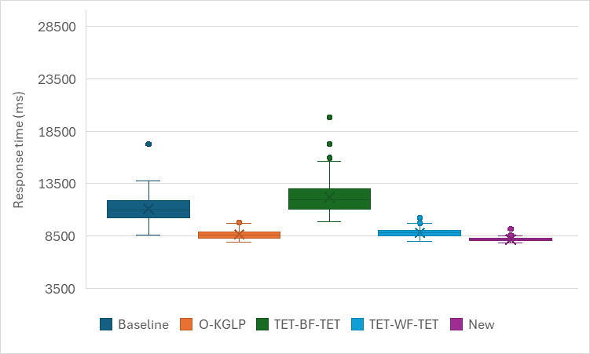  Num_CPU=16, Num_GPU=4 | 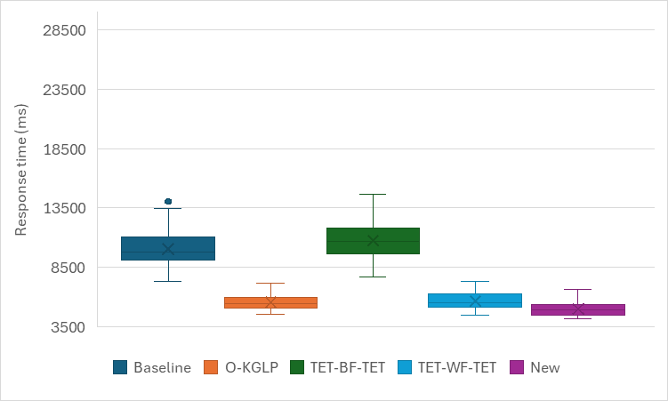  Num_CPU=32, Num_GPU=8
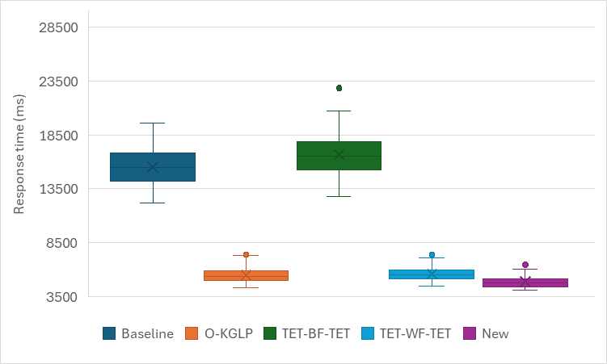
Num_CPU=64, Num_GPU=8

Fig. 5. Simulation results for Case 2 with medium parallelism.

Speedup of the new method (standard deviation)
 | Baseline | O-KGLP | TET-BF-TET | TET-WF-TET
Num_CPU=4, Num_GPU=2 | 30% | 9% | 50% | 9%
Num_CPU=8, Num_GPU=4 | 36% | 1% | 50% | 12%
Num_CPU=16, Num_GPU=4 | 84% | 54% | 88% | 57%
Num_CPU=32, Num_GPU=8 | 52% | -6% | 55% | 2%
Num_CPU=64, Num_GPU=8 | 66% | 12% | 69% | 2%
Average | 53.60% | 14.00% | 62.40% | 16.40%

Low parallelism
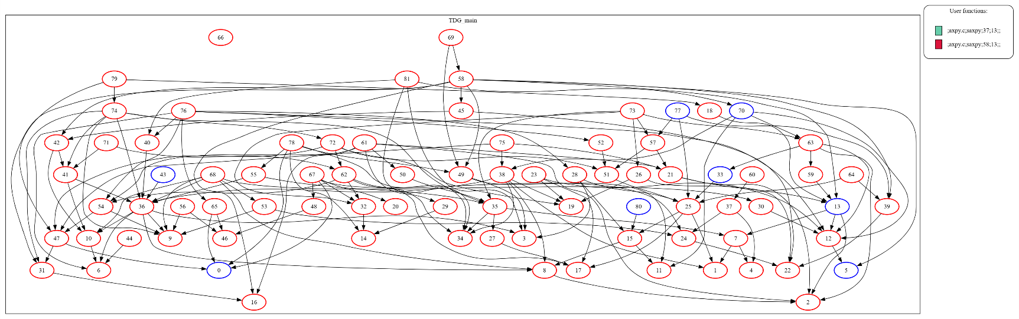
Fig. 6 shows the comparison results obtained with the mapping methods, where there is low parallelism in the system. The comparisons indicate that the WCRT achieved using the proposed approach is lower than that achieved with the others in all the cases. Moreover, the variability of the response times obtained with the new approach is lower in most cases. Furthermore, the difference between the results in Figs 3 and 6 represents that the obtained improvements are more significant when there are more tasks available in this case. However, the main improvements are achieved after increasing the number of CPUs to 8 and the number of GPUs to 4. The reason is that the new algorithms can improve the work-conserving of the mapping process by selecting tasks with shorter execution time and more outgoing tasks, as well as improve the load-balancing of local queues by choosing the queues with shorter execution time. Consequently, the response time and its variability are reduced when executing with many computing elements.

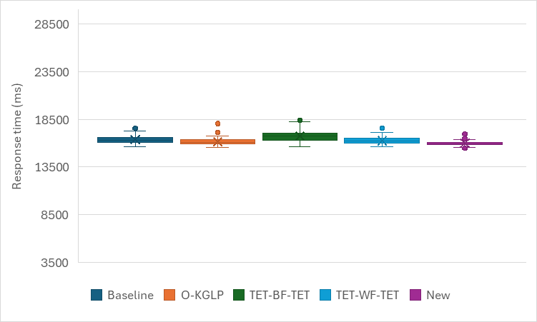  Num_CPU=4, Num_GPU=2 | 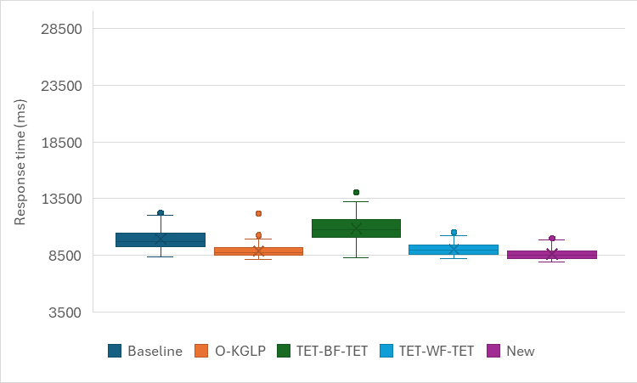  Num_CPU=8, Num_GPU=4
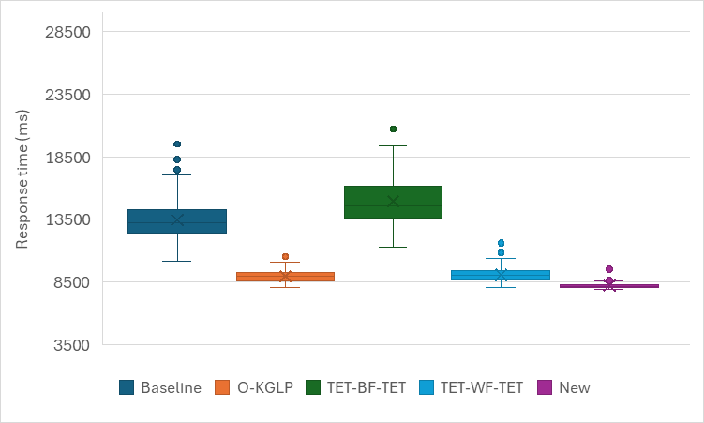  Num_CPU=16, Num_GPU=4 | 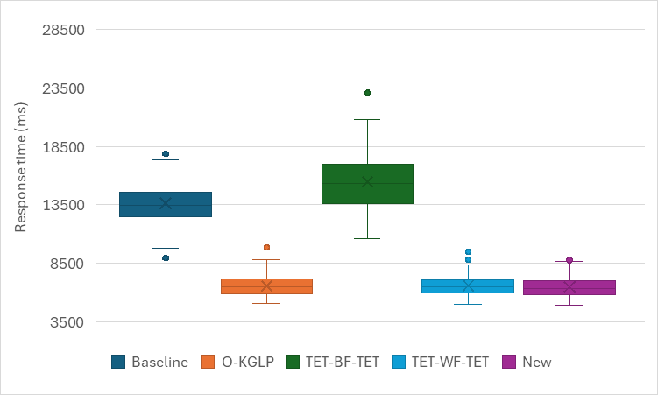  Num_CPU=32, Num_GPU=8
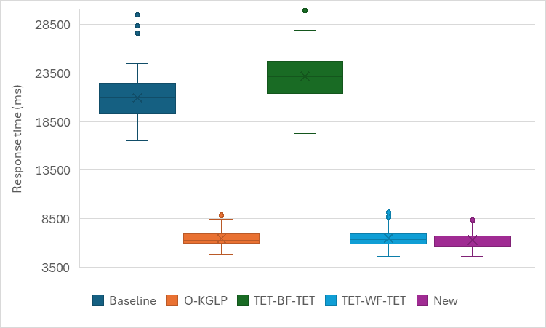
Num_CPU=64, Num_GPU=8
Fig. 6. Simulation results for Case 2 with low parallelism.

Speedup of the new method (standard deviation)
 | Baseline | O-KGLP | TET-BF-TET | TET-WF-TET
Num_CPU=4, Num_GPU=2 | 31% | 18% | 54% | 25%
Num_CPU=8, Num_GPU=4 | 44% | 11% | 55% | 10%
Num_CPU=16, Num_GPU=4 | 81% | 38% | 84% | 49%
Num_CPU=32, Num_GPU=8 | 50% | 0% | 64% | -8%
Num_CPU=64, Num_GPU=8 | 61% | -8% | 60% | 2%
Average | 53.40% | 11.80% | 63.40% | 15.60%

Case 3 (number of GPU tasks = 99, number of CPU tasks = 10)
High parallelism
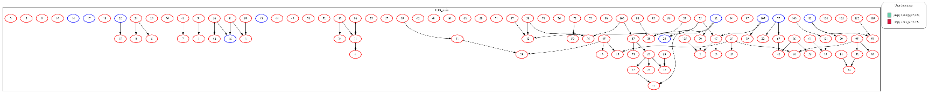

Fig. 7 shows the considerable improvements obtained with the proposed approach compared to the others, especially when executing tasks with the largest number of computing elements. This is due to the high number of parallel executing tasks in this case, compared to the other cases, due to the high number of tasks executed, as well as the low number of data dependencies. This demonstrates that selecting shorter tasks from the global queue and selecting tasks with the maximum all outgoing tasks from local queues can increase the number of ready tasks in the system and facilitate the mapping process. Furthermore, selecting local queues with the shortest execution time for the task allocation process can increase the workload of the queues and, consequently, improve parallel execution and task response time.
By comparing the results obtained in Figs. 1, 4, and 7, it can be demonstrated that the performance of the new approach improves with an increase in the number of tasks. This achievement is even more notable when more computing elements are applied to task execution, since the algorithms used in this approach have more chance to select the most appropriate resources for execution.

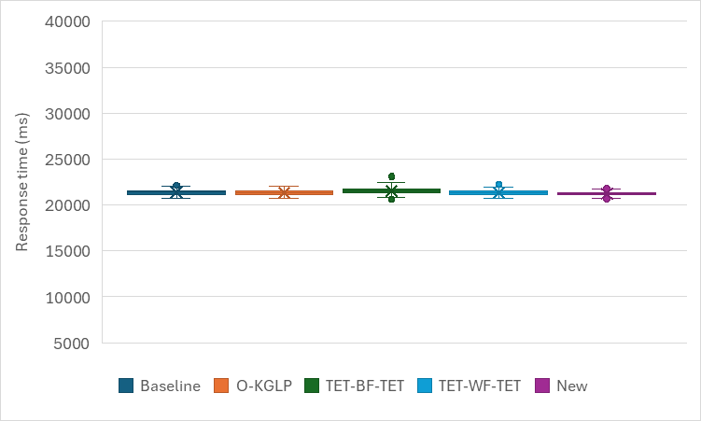  Num_CPU=4, Num_GPU=2 | 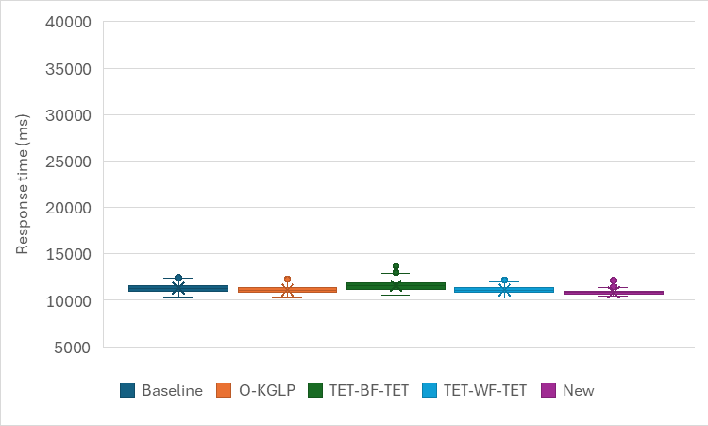  Num_CPU=8, Num_GPU=4
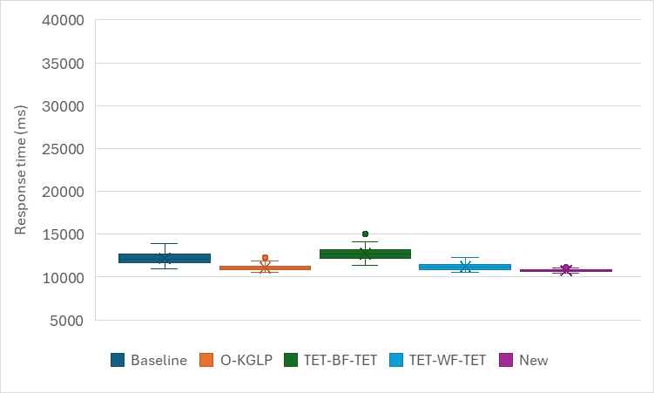  Num_CPU=16, Num_GPU=4 | 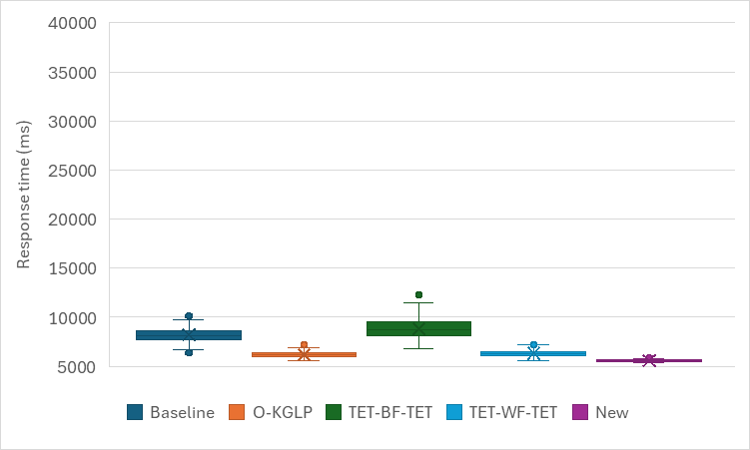  Num_CPU=32, Num_GPU=8
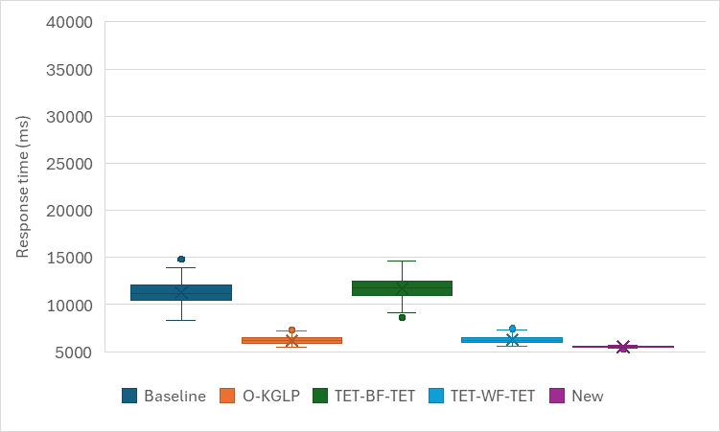
Num_CPU=64, Num_GPU=8
Fig. 7. Simulation results for Case 3 with high parallelism.

Speedup of the new method (standard deviation)
 | Baseline | O-KGLP | TET-BF-TET | TET-WF-TET
Num_CPU=4, Num_GPU=2 | 27% | 20% | 39% | 29%
Num_CPU=8, Num_GPU=4 | 46% | 23% | 47% | 24%
Num_CPU=16, Num_GPU=4 | 78% | 60% | 79% | 65%
Num_CPU=32, Num_GPU=8 | 84% | 65% | 90% | 71%
Num_CPU=64, Num_GPU=8 | 93% | 80% | 93% | 79%
Average | 65.60% | 49.60% | 69.60% | 53.60%

Medium parallelism
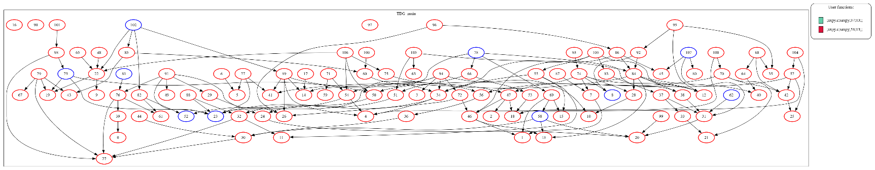

Fig. 8 illustrates task execution in Case 3, where the number of task data dependencies is medium. The comparison results indicate that the WCRT obtained with the proposed approach is lower than that obtained with the other approaches. However, the response time variability achieved with the new approach is slightly lower than the others. The improvements are quite noticeable in the cases executed with 16 GPUs and 4 CPUs. The reason is that the number of parallel executing tasks is medium, so these computing elements are sufficient. In this way, selecting tasks based on the shortest execution time (increasing the number of next ready tasks) and the largest outgoing tasks (increasing the number of ready tasks in the system) can improve the work-conserving of the mapping process, as well as selecting queues based on the shortest execution time can enhance the load-balancing of queues, therefore optimizing task execution and reducing response time.
The comparison results obtained in Figs. 2, 5, and 8 illustrate that, when the amount of computing resources is high, the improvements obtained in Fig. 8 are higher than those obtained in the previous cases. The reason is that the number of tasks in this case, as well as the number of CPUs and GPUs, is high, so tasks are distributed across multiple allocation queues through a balanced way, and consequently, the response time is reduced.
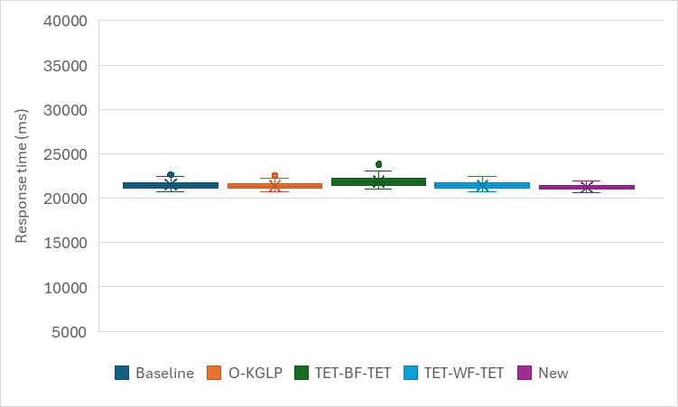  Num_CPU=4, Num_GPU=2 | 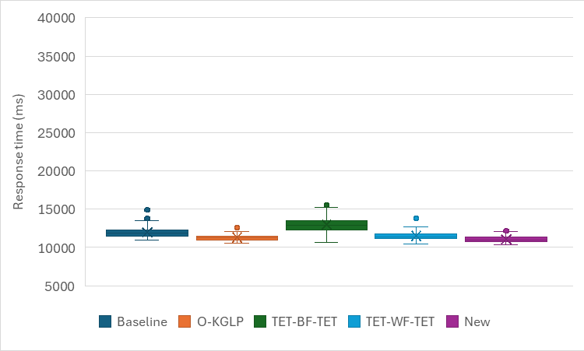  Num_CPU=8, Num_GPU=4
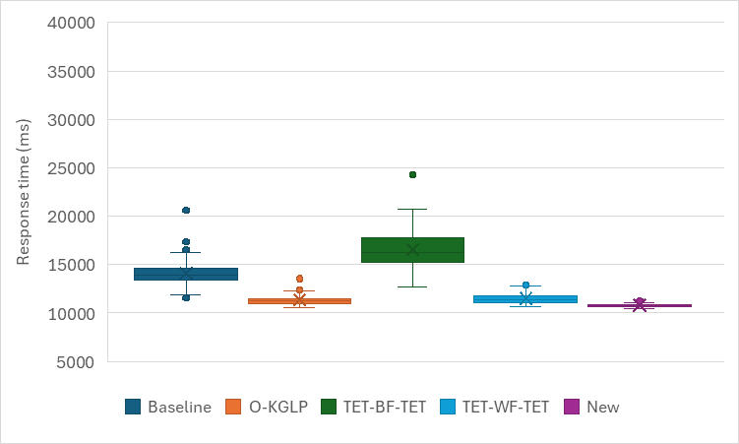  Num_CPU=16, Num_GPU=4 | 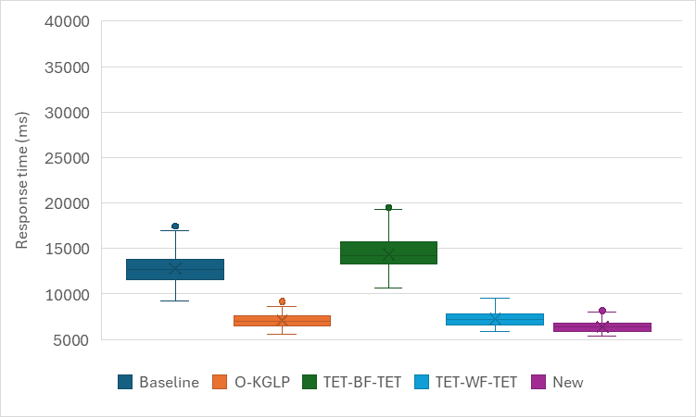  Num_CPU=32, Num_GPU=8
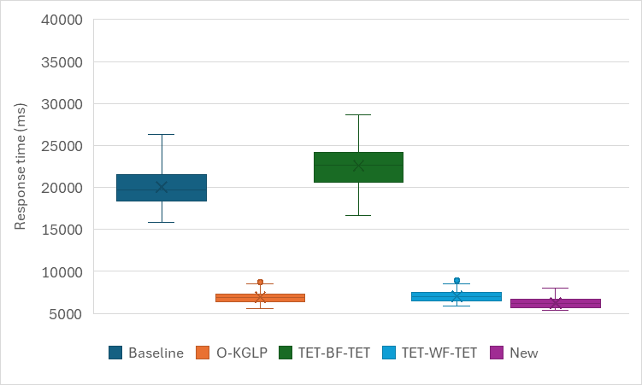
Num_CPU=64, Num_GPU=8
Fig. 8. Simulation results for Case 3 with medium parallelism.
Speedup of the new method (standard deviation)
 | Baseline | O-KGLP | TET-BF-TET | TET-WF-TET
Num_CPU=4, Num_GPU=2 | 41% | 22% | 54% | 34%
Num_CPU=8, Num_GPU=4 | 38% | 7% | 60% | 23%
Num_CPU=16, Num_GPU=4 | 83% | 53% | 88% | 58%
Num_CPU=32, Num_GPU=8 | 59% | 3% | 64% | 14%
Num_CPU=64, Num_GPU=8 | 72% | 15% | 76% | 17%
Average | 58.60% | 20.00% | 68.40% | 29.20%

Low parallelism
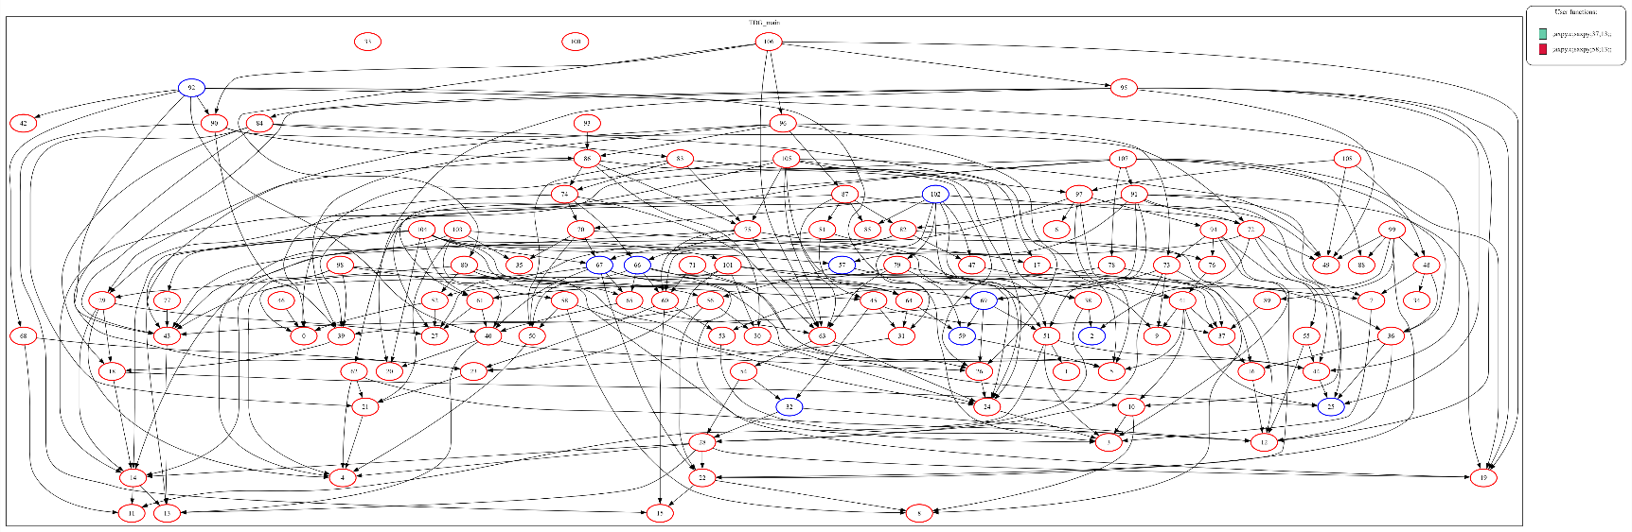

Fig. 9 shows similar improvements obtained with the new approach in this case, where there are many data dependencies between tasks. As the number of parallel executing tasks is low, it is more efficient to use medium computing elements, where the number of CPUs is 16 and the number of GPUs is 4. Comparing the results in Figs. 3, 6, and 9 shows that the improvements obtained using the new approach in Fig. 9 are superior to those obtained in Figs. 3 and 6 in most cases. This indicates that the used algorithms can improve the work-conserving of mapping and the load-balancing of queues based on task execution time and the number of outgoing tasks in the system.

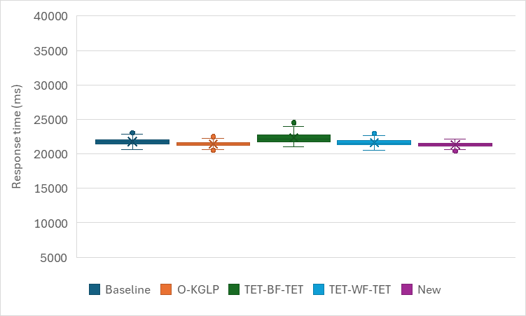  Num_CPU=4, Num_GPU=2 | 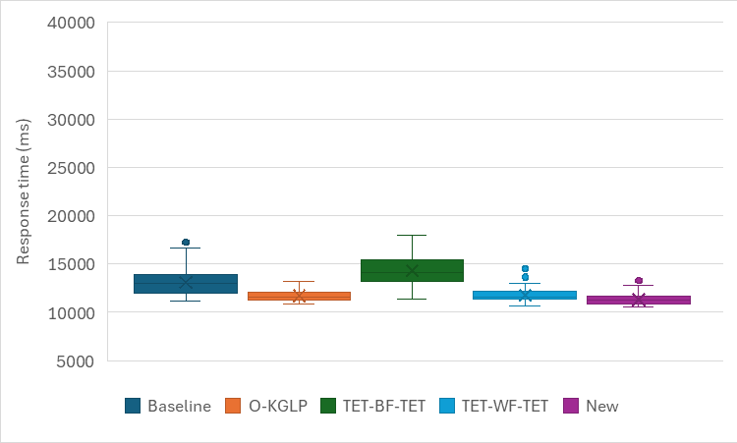  Num_CPU=8, Num_GPU=4
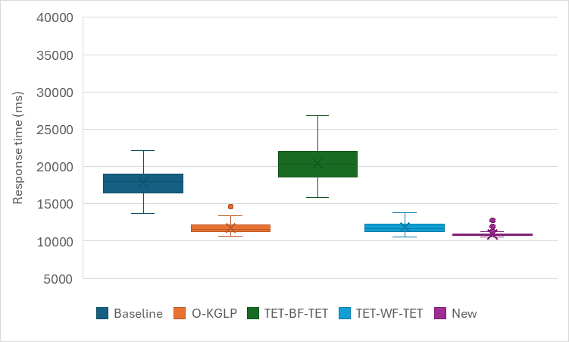  Num_CPU=16, Num_GPU=4 | 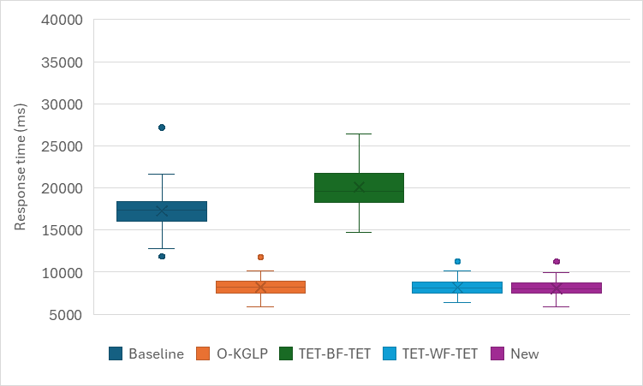  Num_CPU=32, Num_GPU=8
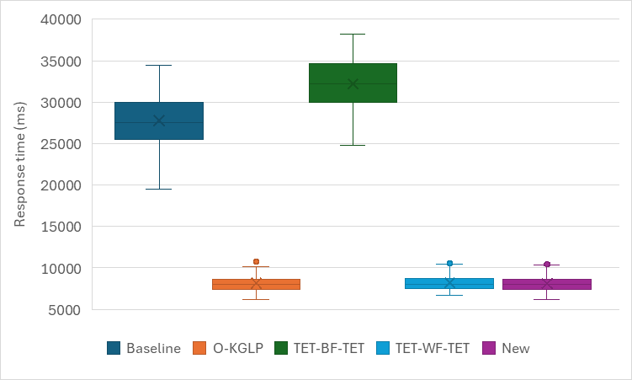
Num_CPU=64, Num_GPU=8
Fig. 9. Simulation results for Case 3 with low parallelism.

Speedup of the new method (standard deviation)
 | Baseline | O-KGLP | TET-BF-TET | TET-WF-TET
Num_CPU=4, Num_GPU=2 | 39% | 26% | 63% | 32%
Num_CPU=8, Num_GPU=4 | 54% | -2% | 61% | 7%
Num_CPU=16, Num_GPU=4 | 82% | 49% | 87% | 55%
Num_CPU=32, Num_GPU=8 | 57% | -4% | 63% | -4%
Num_CPU=64, Num_GPU=8 | 68% | -5% | 67% | -3%
Average | 60.00% | 12.80% | 68.20% | 17.40%

The overall evaluation results indicate that the performance of the proposed approach is more noticeable when the number of parallel executing tasks is high (high parallelism), especially in the case of using more computing elements (CPUs and GPUs). The reason are that (i) the most appropriate tasks can be selected using the algorithms used for task and local queue selections, where tasks with shorter execution time or tasks with more outgoing tasks are selected, which increases the number of ready tasks by meeting their input data dependencies, and (ii) the most suitable local queues are selected for tasks, which include the shortest total execution time, improving the parallel execution of tasks using many resources and therefore reducing the response time and its variability.

Case 4 (number of GPU tasks = 124, number of CPU tasks = 12)
High parallelism
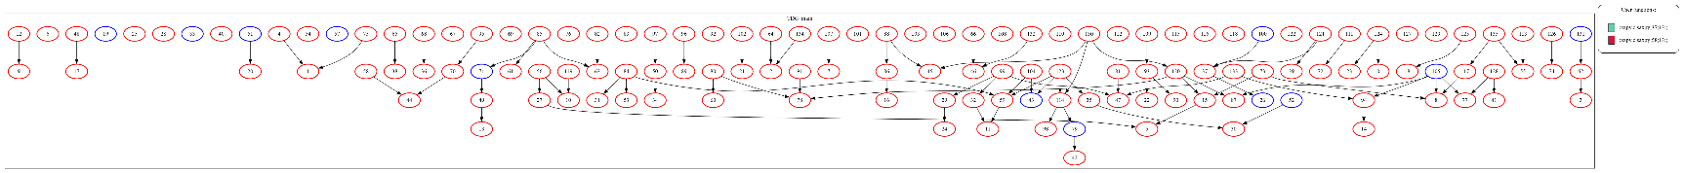

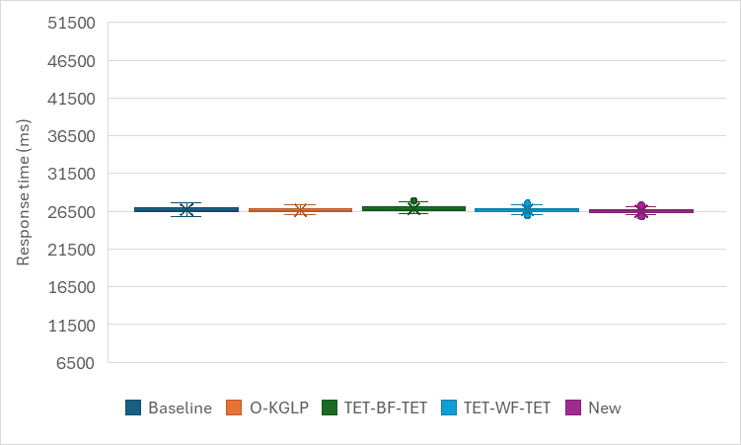  Num_CPU=4, Num_GPU=2 | 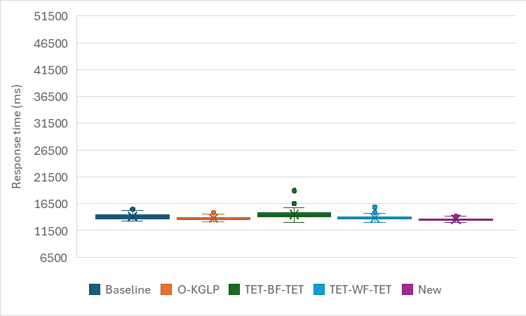  Num_CPU=8, Num_GPU=4
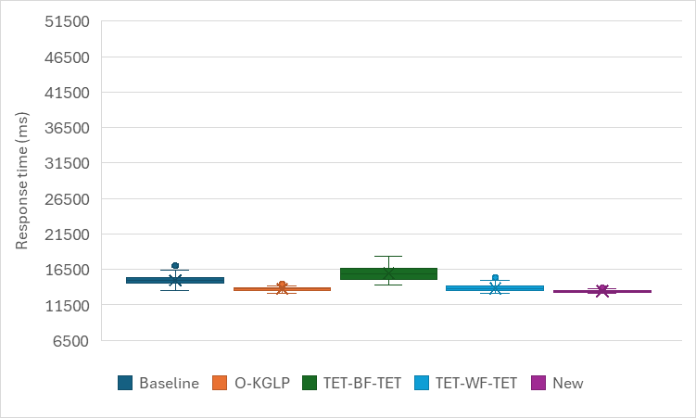  Num_CPU=16, Num_GPU=4 | 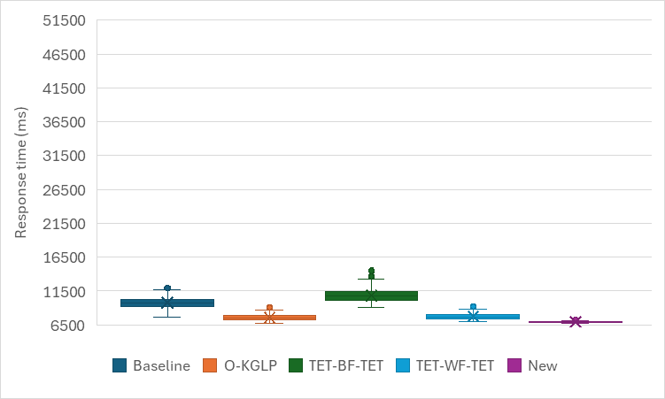  Num_CPU=32, Num_GPU=8
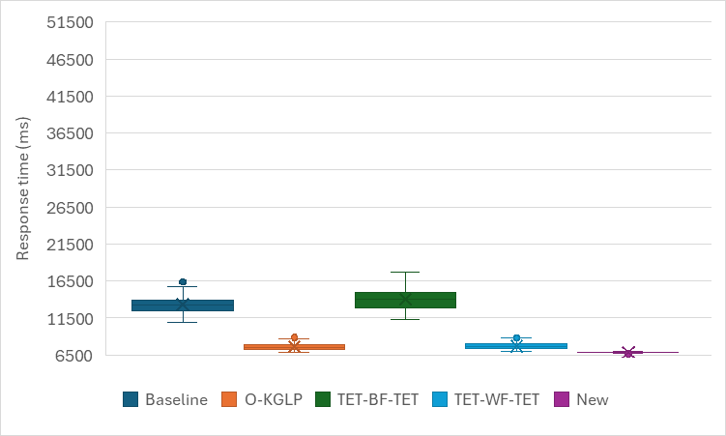
Num_CPU=64, Num_GPU=8
Fig. 10. Simulation results for Case 4 with high parallelism.

Speedup of the new method (standard deviation)
 | Baseline | O-KGLP | TET-BF-TET | TET-WF-TET
Num_CPU=4, Num_GPU=2 | 26% | 9% | 43% | 25%
Num_CPU=8, Num_GPU=4 | 44% | 14% | 62% | 33%
Num_CPU=16, Num_GPU=4 | 74% | 46% | 81% | 57%
Num_CPU=32, Num_GPU=8 | 83% | 66% | 86% | 65%
Num_CPU=64, Num_GPU=8 | 93% | 81% | 94% | 80%
Average | 64.00% | 43.20% | 73.20% | 52.00%

Medium parallelism
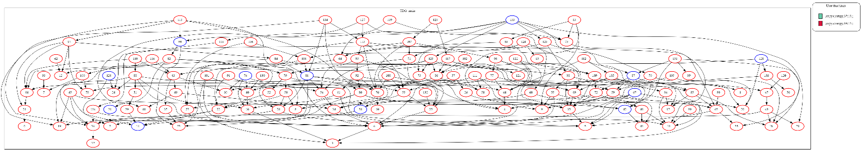
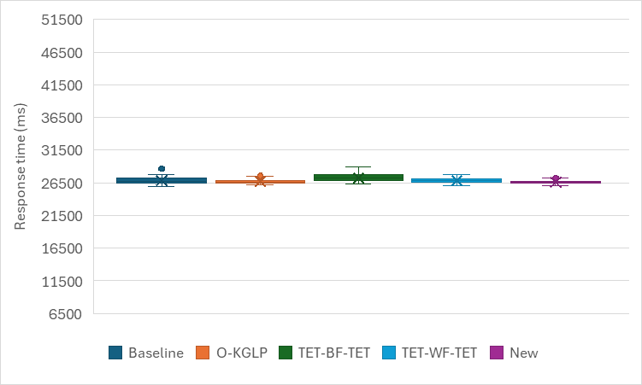  Num_CPU=4, Num_GPU=2 | 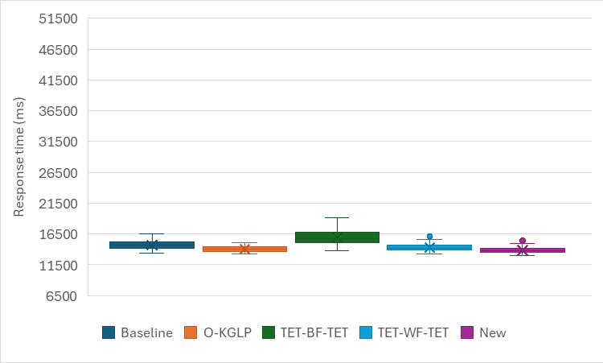  Num_CPU=8, Num_GPU=4
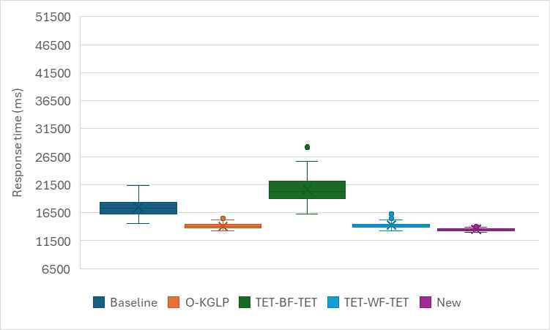  Num_CPU=16, Num_GPU=4 | 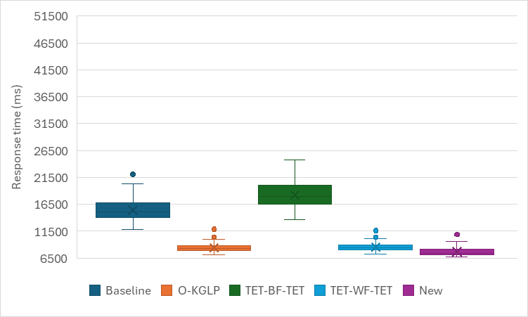  Num_CPU=32, Num_GPU=8
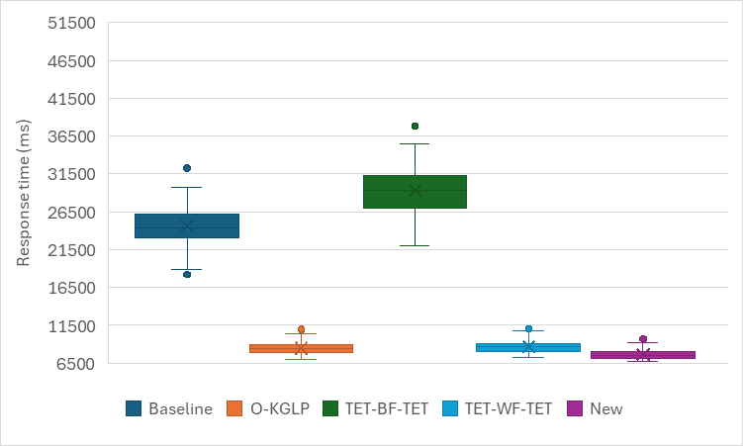
Num_CPU=64, Num_GPU=8
Fig. 11. Simulation results for Case 4 with medium parallelism.

Speedup of the new method (standard deviation)
 | Baseline | O-KGLP | TET-BF-TET | TET-WF-TET
Num_CPU=4, Num_GPU=2 | 43% | 16% | 55% | 21%
Num_CPU=8, Num_GPU=4 | 35% | 4% | 61% | 17%
Num_CPU=16, Num_GPU=4 | 81% | 34% | 87% | 52%
Num_CPU=32, Num_GPU=8 | 62% | -4% | 68% | 1%
Num_CPU=64, Num_GPU=8 | 75% | 14% | 81% | 22%
Average | 59.20% | 12.80% | 70.40% | 22.60%

Low parallelism
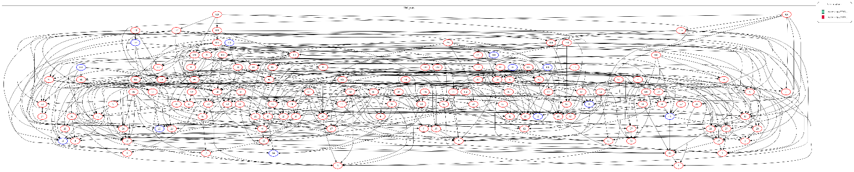

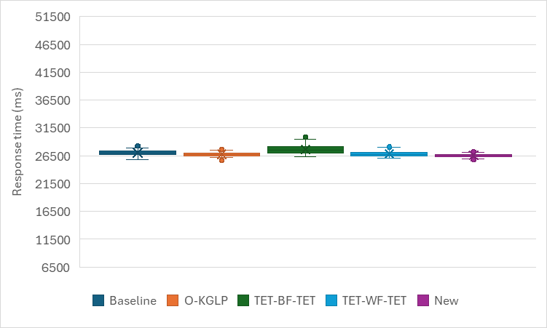  Num_CPU=4, Num_GPU=2 | 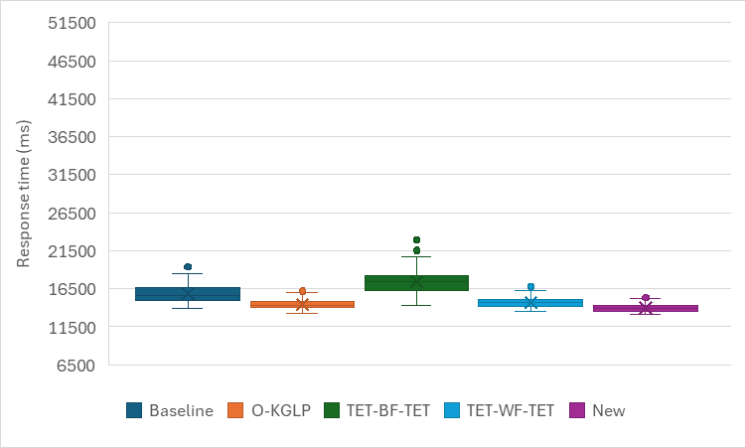  Num_CPU=8, Num_GPU=4
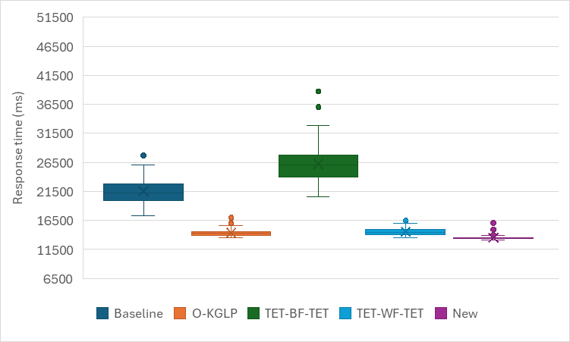  Num_CPU=16, Num_GPU=4 | 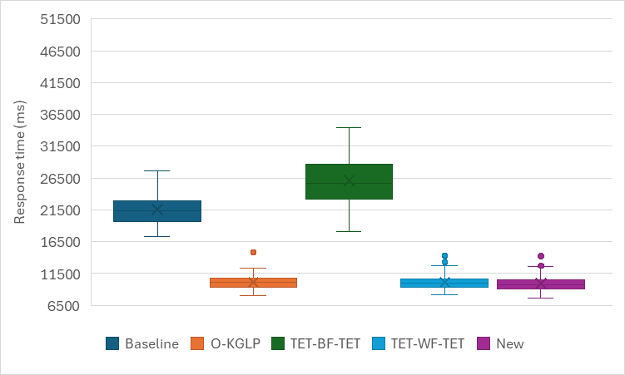  Num_CPU=32, Num_GPU=8
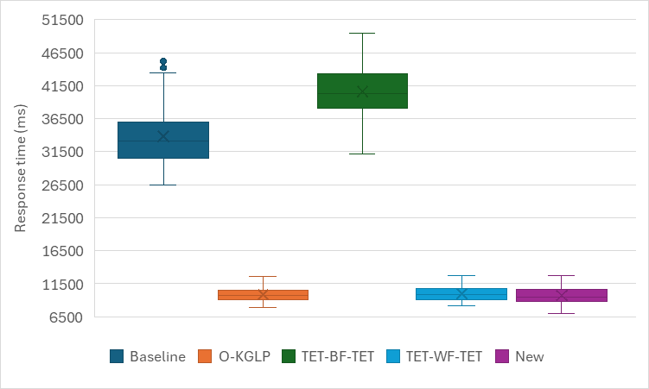
Num_CPU=64, Num_GPU=8
Fig. 12. Simulation results for Case 4 with low parallelism.

Speedup of the new method (standard deviation)
 | Baseline | O-KGLP | TET-BF-TET | TET-WF-TET
Num_CPU=4, Num_GPU=2 | 38% | 10% | 53% | 25%
Num_CPU=8, Num_GPU=4 | 56% | 16% | 70% | 24%
Num_CPU=16, Num_GPU=4 | 82% | 42% | 89% | 41%
Num_CPU=32, Num_GPU=8 | 48% | -8% | 65% | -3%
Num_CPU=64, Num_GPU=8 | 72% | -17% | 69% | -12%
Average | 59.20% | 8.60% | 69.20% | 15.00%

